Git and Git hub

Different type of repositories for code

1. GIT—most popular
2. SVN
3. TFS
4. VSTS

url github.com

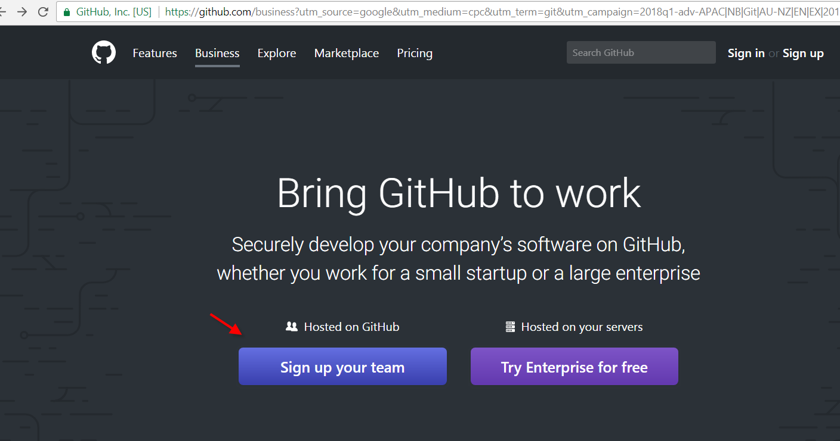

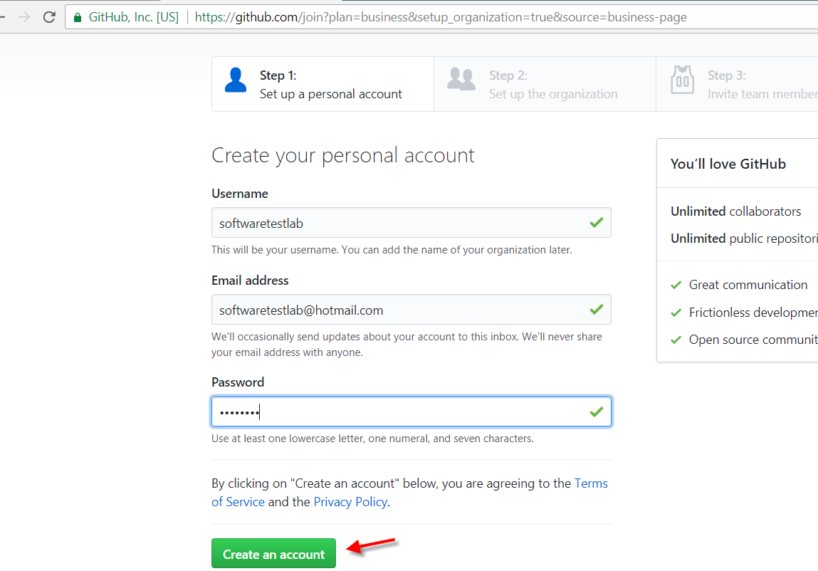

Go to your email and click on verify email, then below screen appears

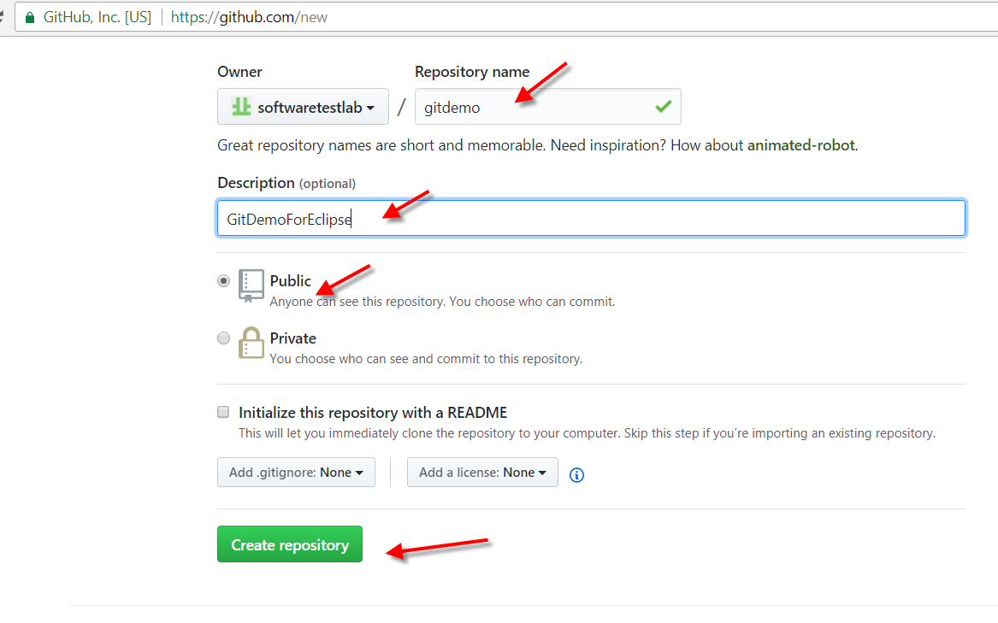

System navigates to below screen

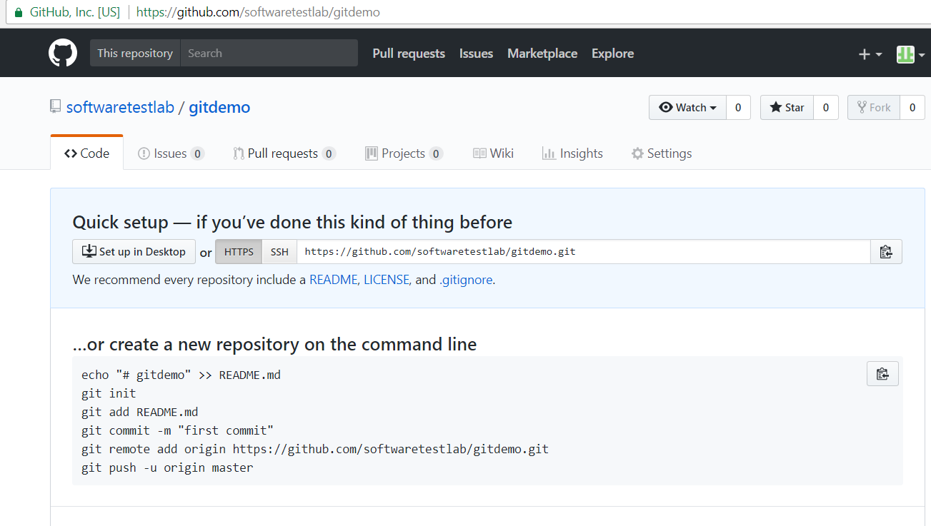

Now lets go back to eclipse and select the path of project

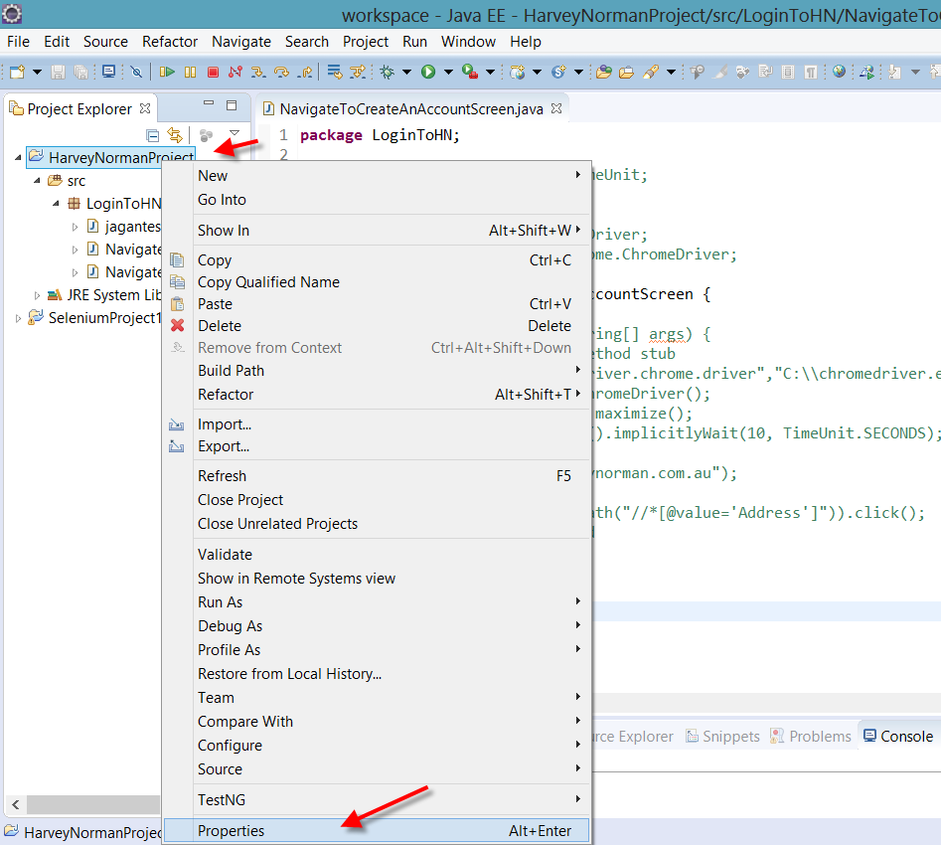

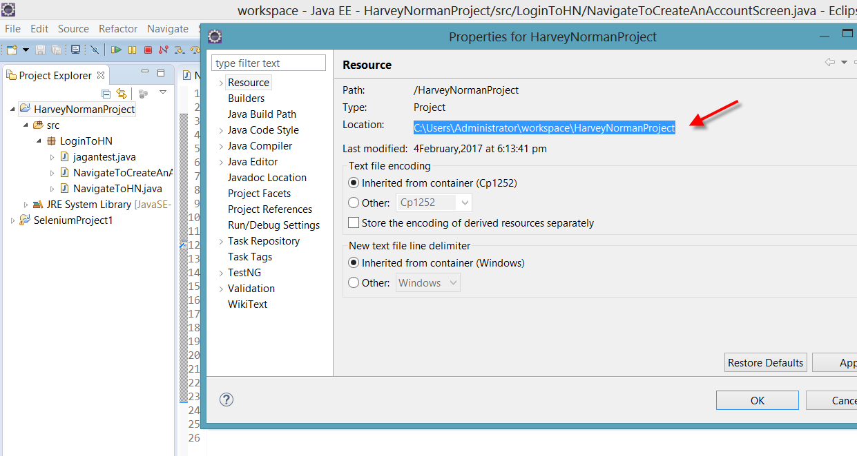

Install git, by going to below link

<https://www.atlassian.com/git/tutorials/install-git#windows>

or

<http://gitforwindows.org/>

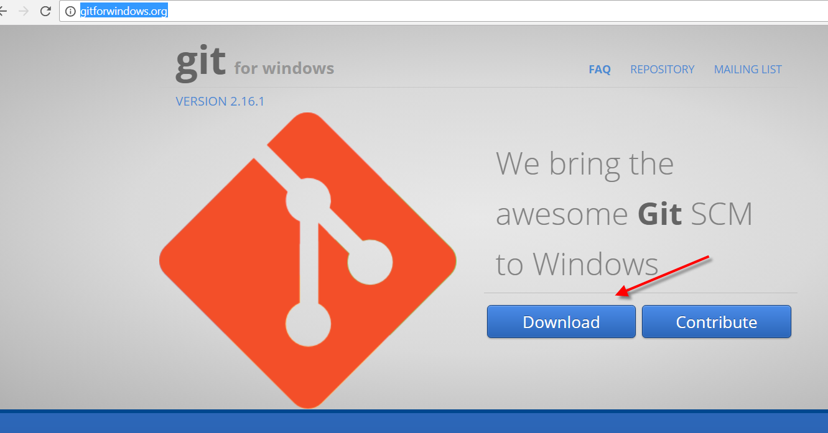

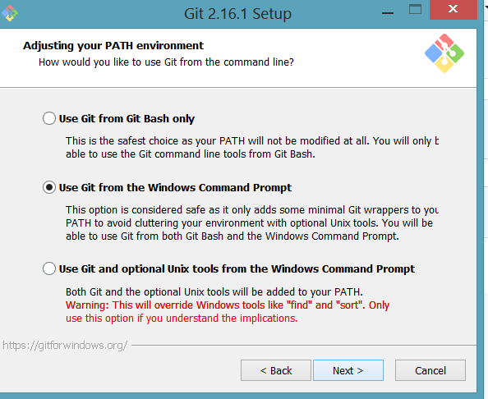

Just click next on installation ..dont change anything

Once git is installed go to cmd and enter the path of the project

cd C:\Users\Administrator\workspace\HarveyNormanProject

then enter

git init

now you will see git repository created

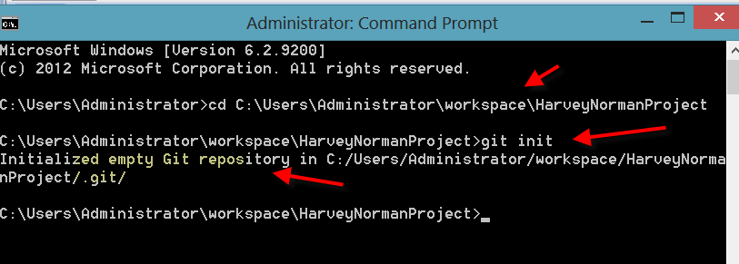

In c drive you can see git

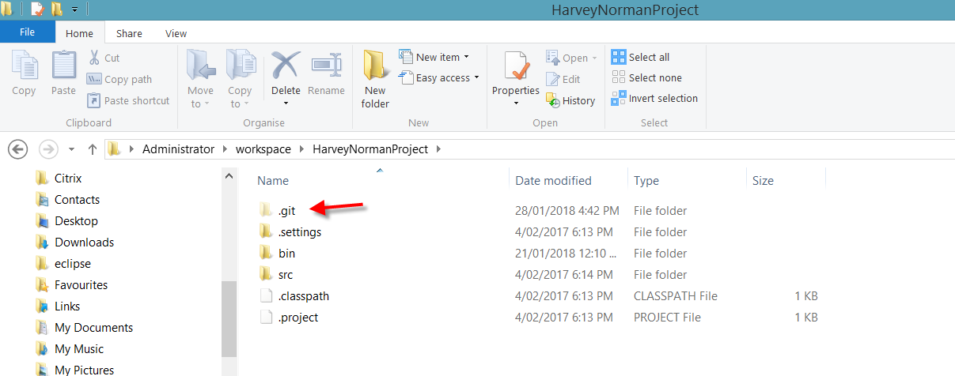

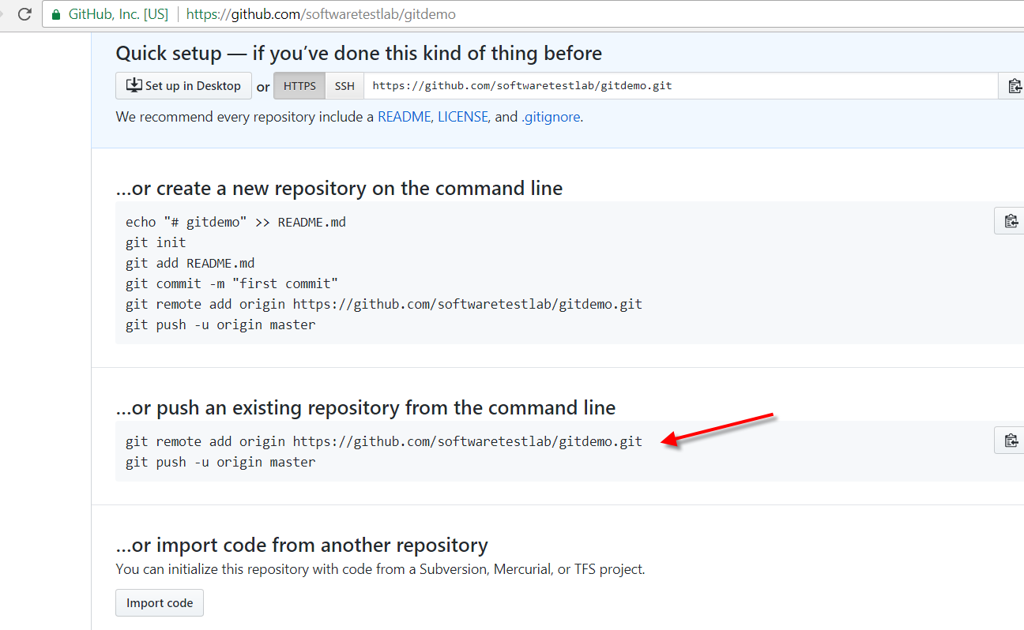

Copy above code and paste in cmd

git remote add origin https://github.com/softwaretestlab/gitdemo.git

This is how we create a link between git and our machine

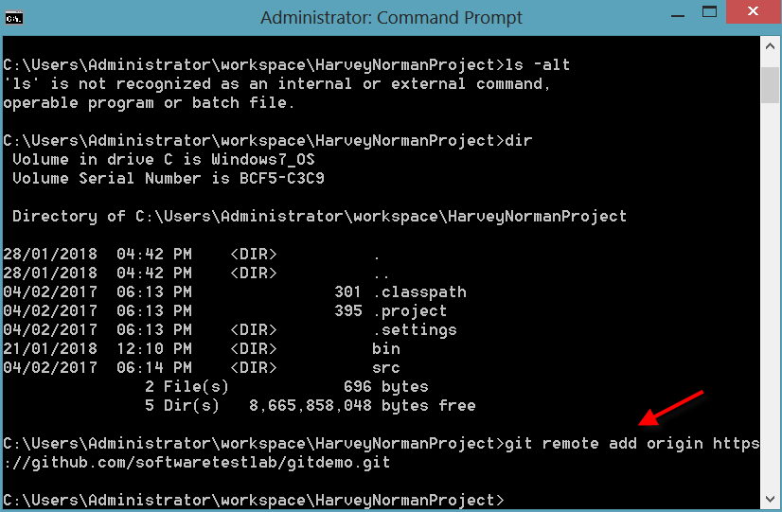

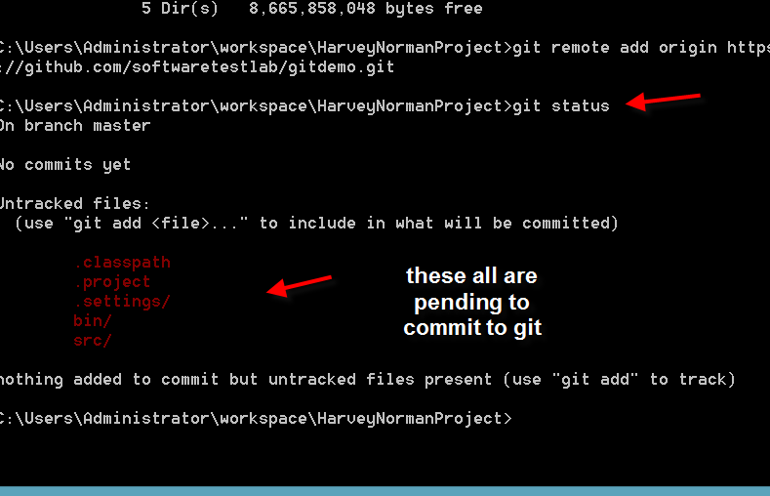

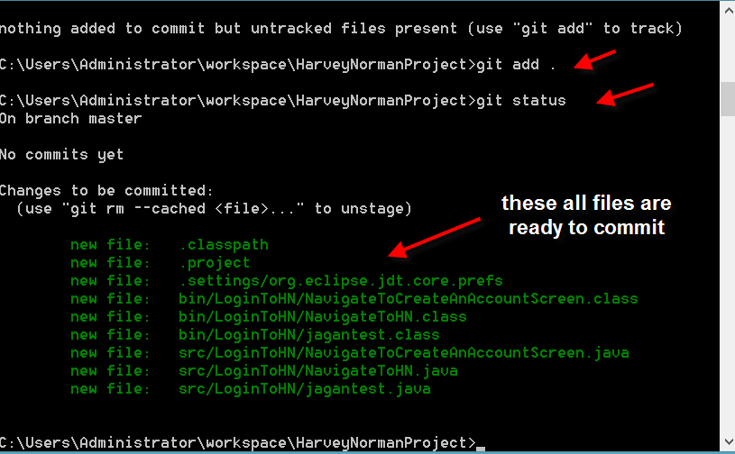

Enter git commit –m “any text”

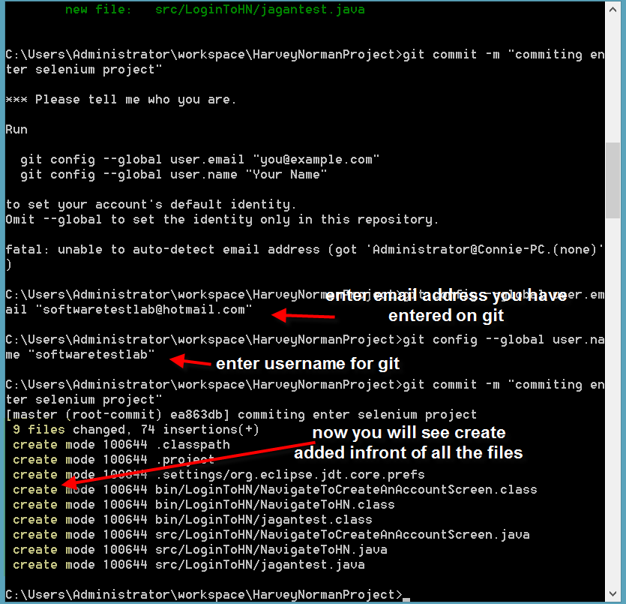

Now lets create ssl key

1. Open Git Bash.
2. Paste the text below, substituting in your GitHub email address.
3. ssh-keygen -t rsa -b 4096 -C "your_email@example.com"

This creates a new ssh key, using the provided email as a label.

Generating public/private rsa key pair.

1. When you're prompted to "Enter a file in which to save the key," press Enter. This accepts the default file location.
2. Enter a file in which to save the key (/c/Users/you/.ssh/id_rsa):[Press enter]
3. At the prompt, type a secure passphrase. For more information, see ["Working with SSH key passphrases"](https://help.github.com/articles/working-with-ssh-key-passphrases).
4. Enter passphrase (empty for no passphrase): [Type a passphrase]
5. Enter same passphrase again: [Type passphrase again]

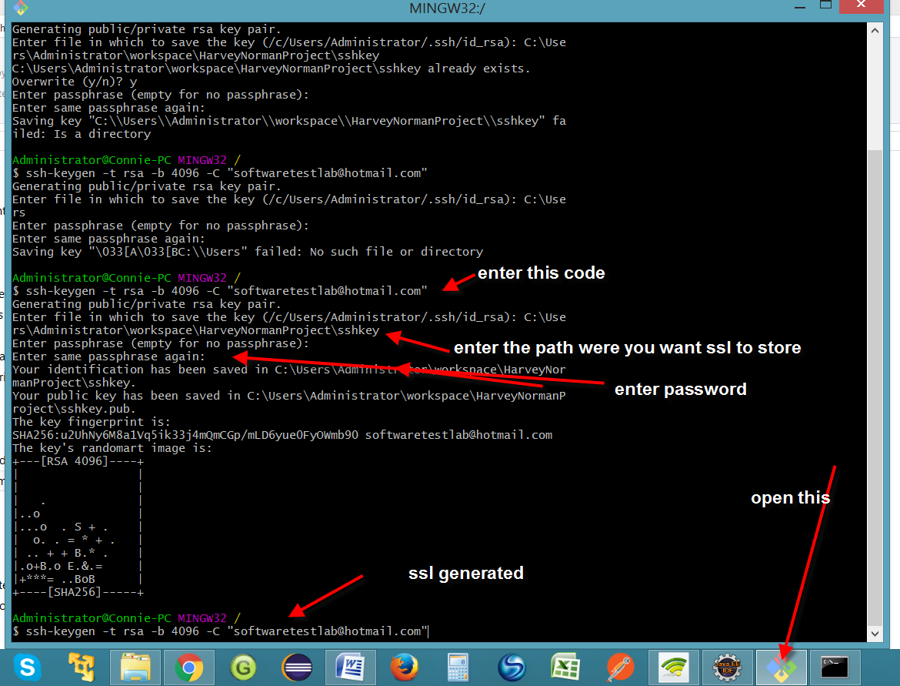

Now go to the folder were its created and copy ssl key

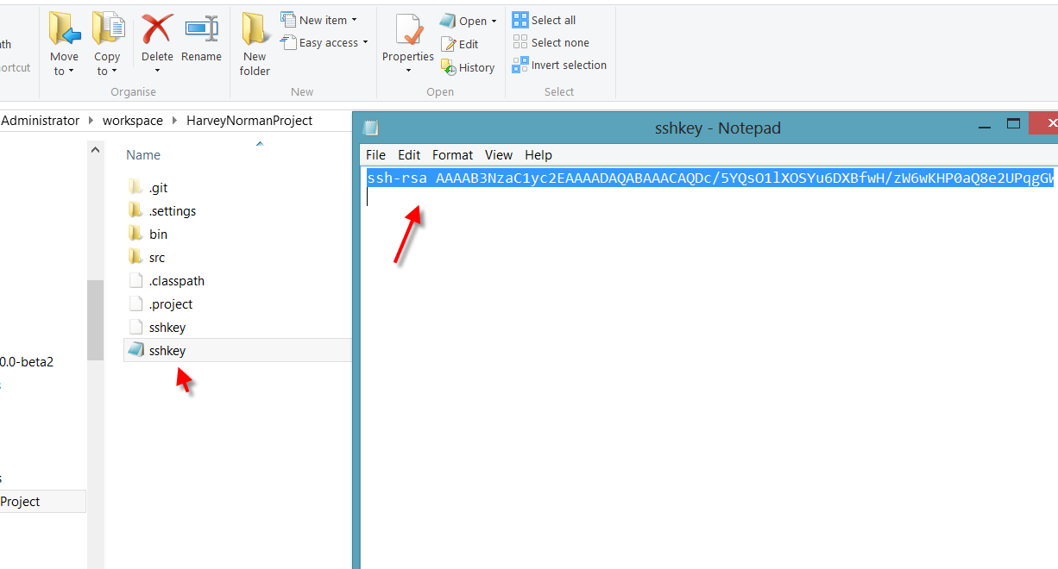

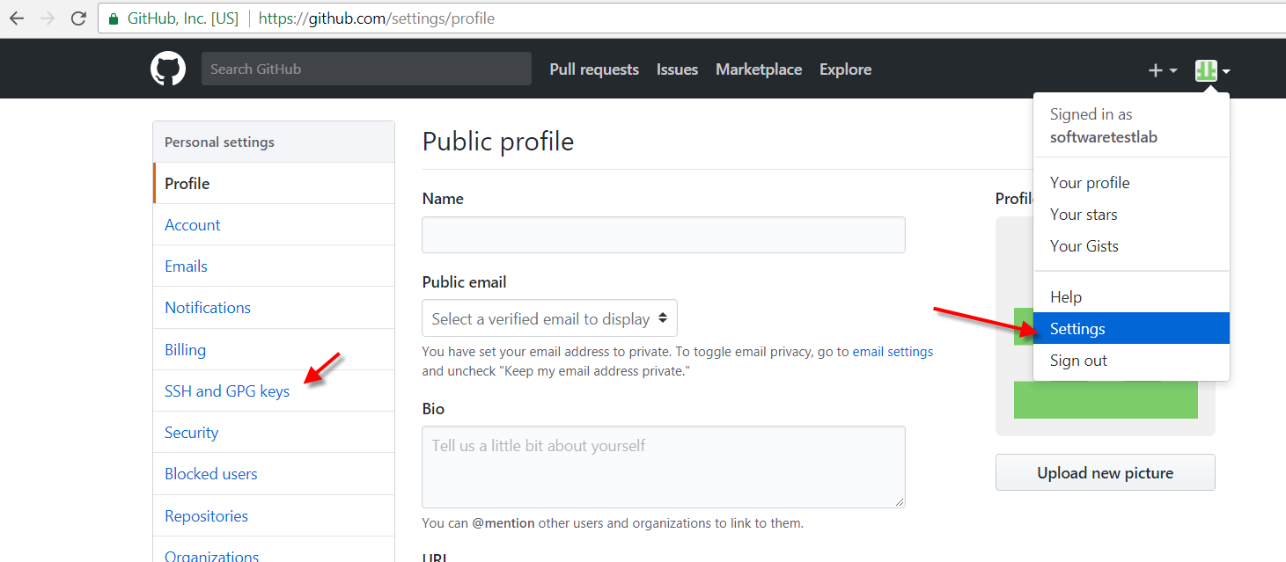

Paste the key in key section and click on add ssh key

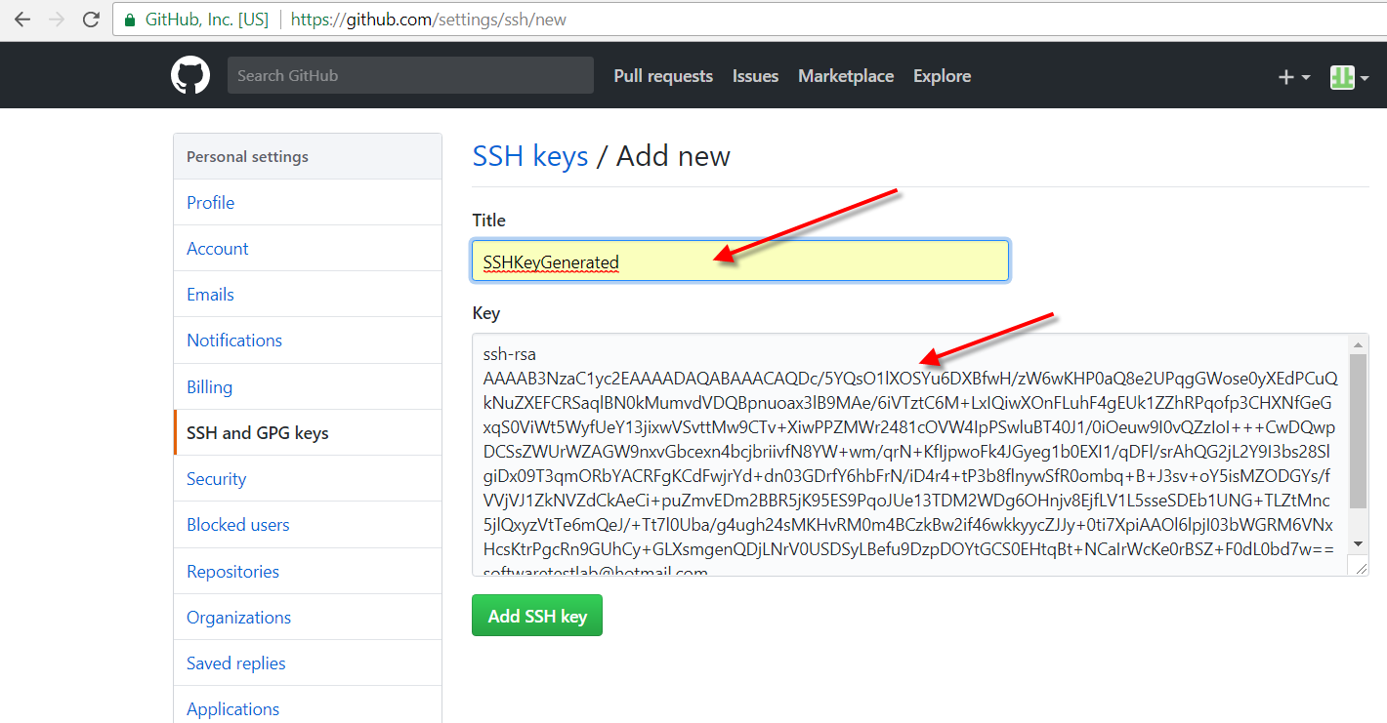

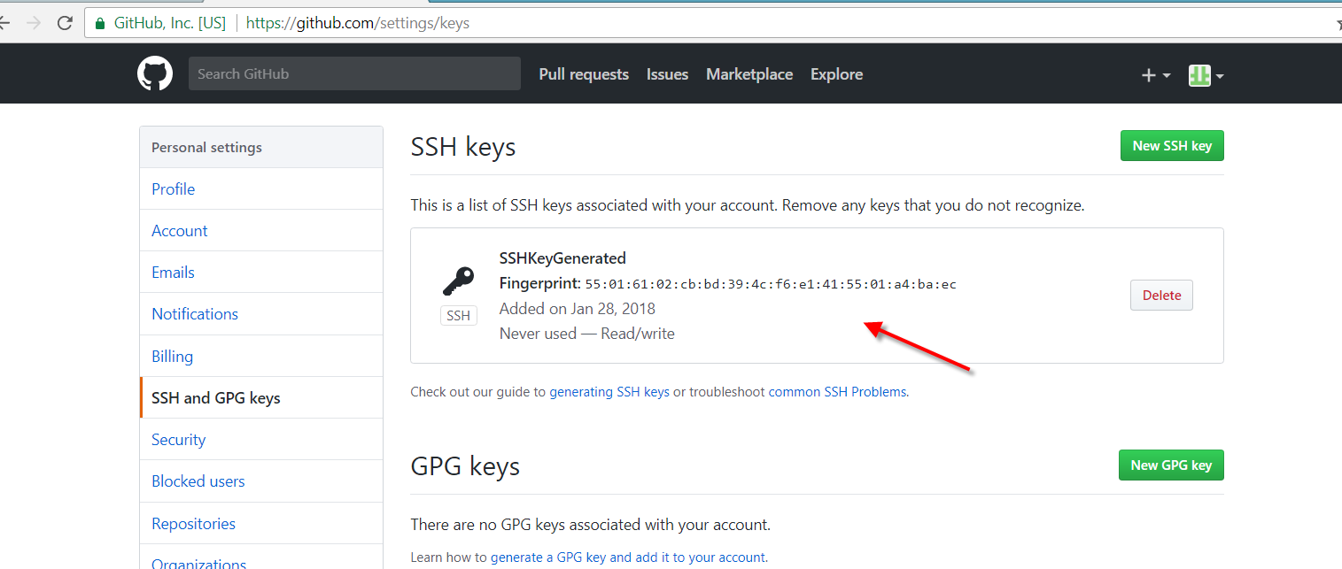

Now go back to cmd and enter

git push origin master

Then enter username password for git

Now it will push all the code to git

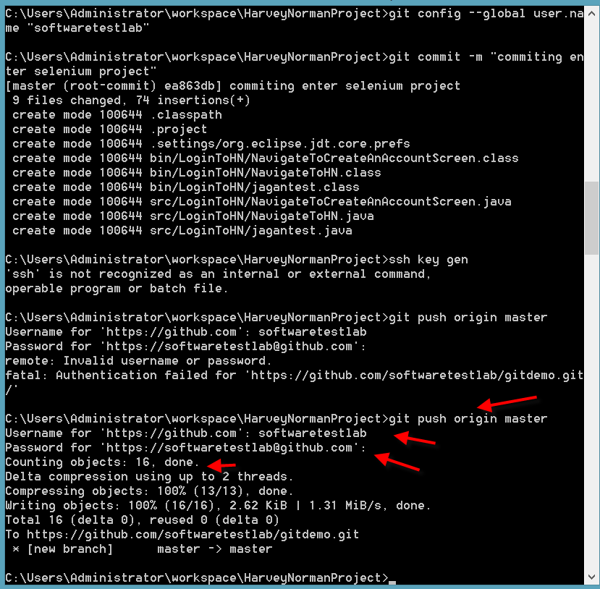

Now lets see all the code on git

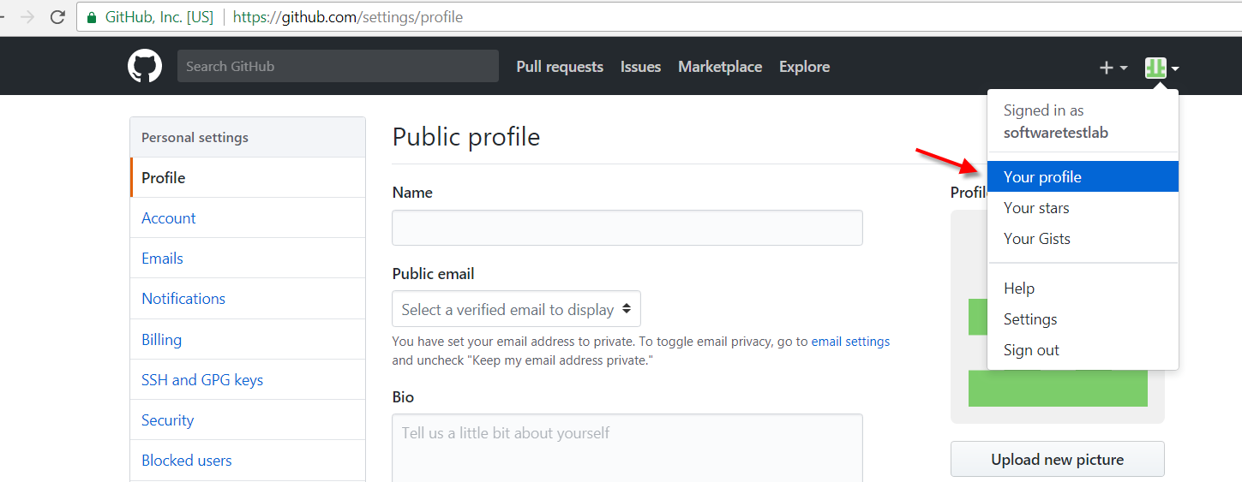

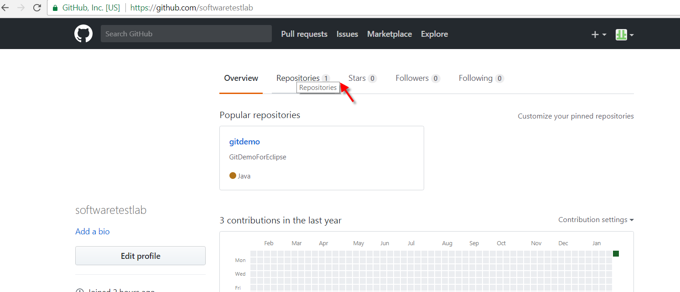

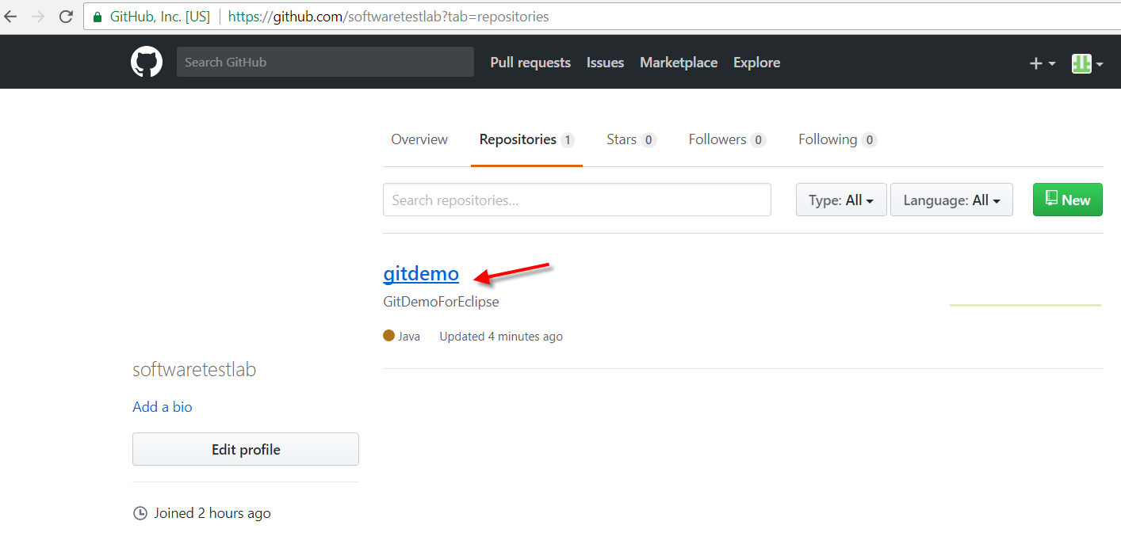

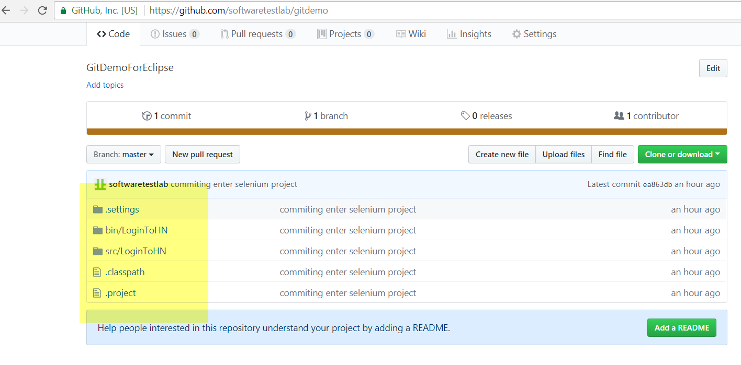

Now check on eclipse..all the code from here is copied to git

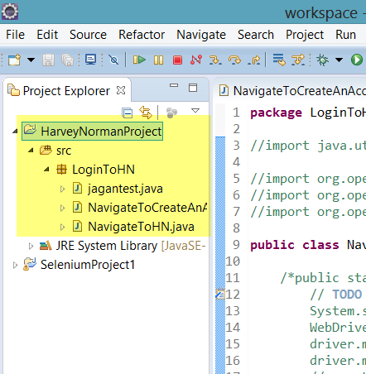

Now let’s create a new class in eclipse and push this change to git

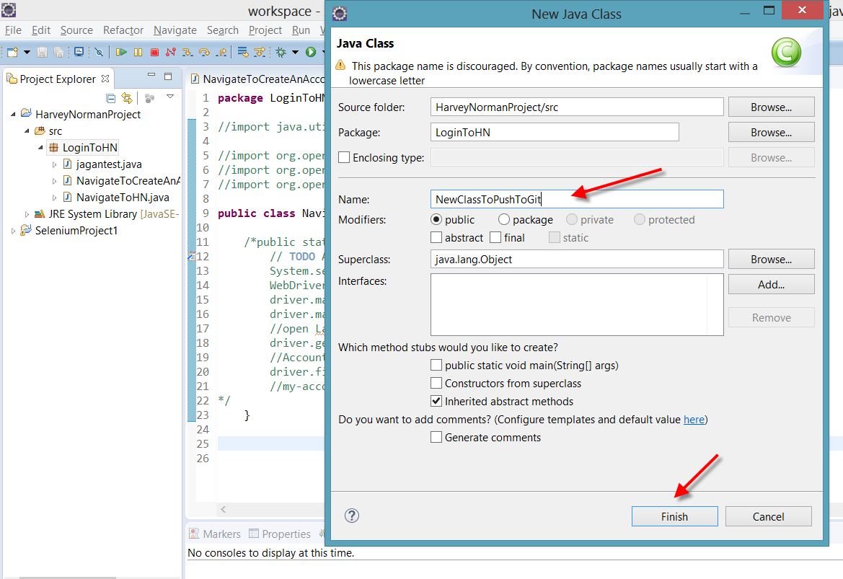

I have created a new class with couple of methods inside it

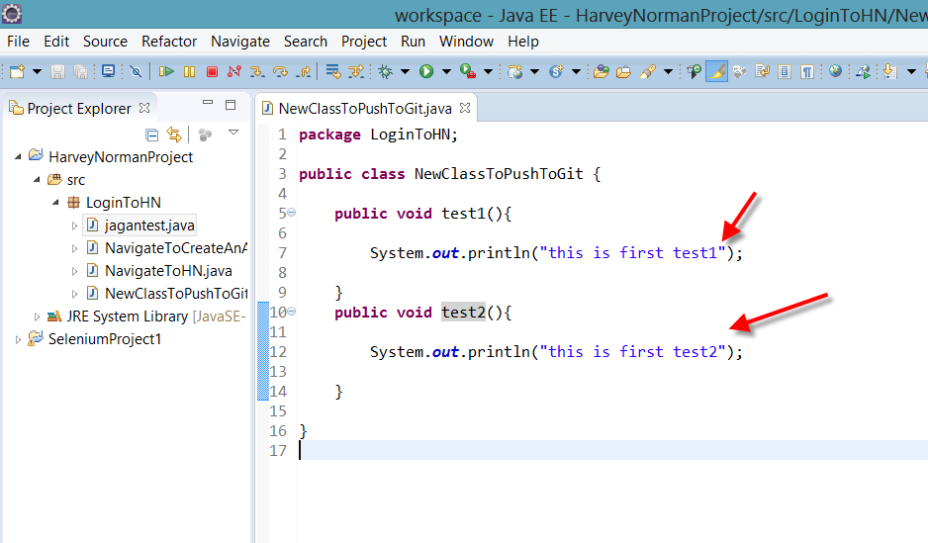

Now lets go to cmd

Git status

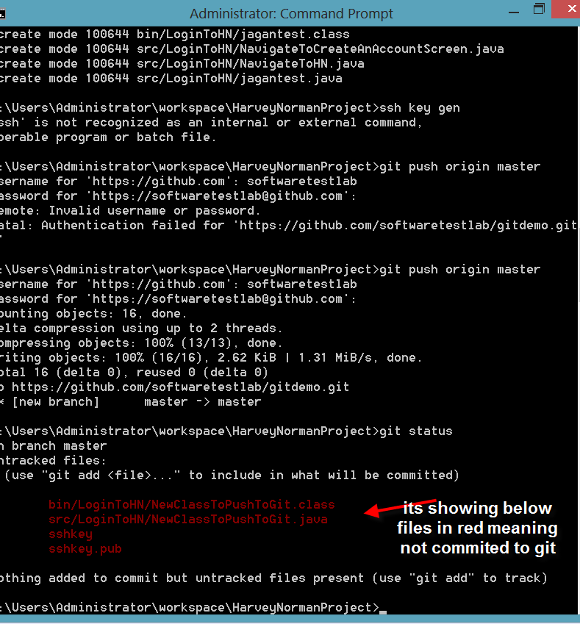

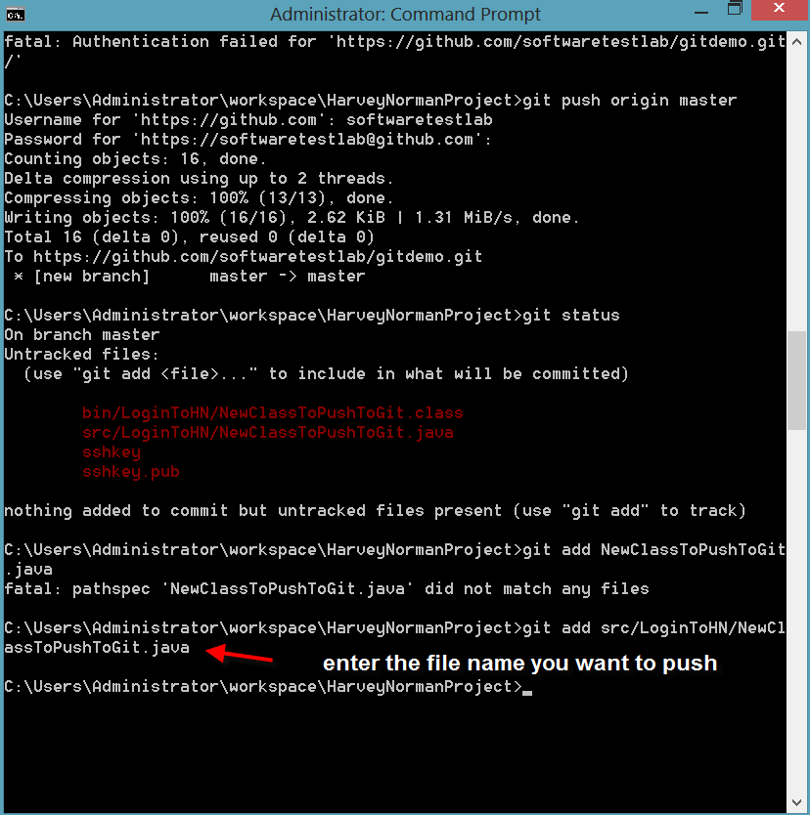

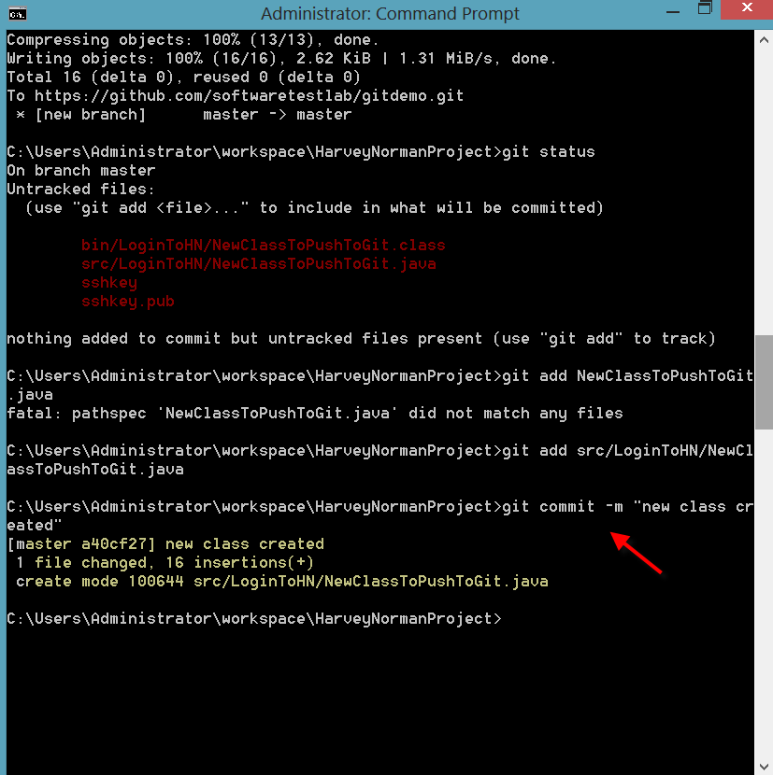

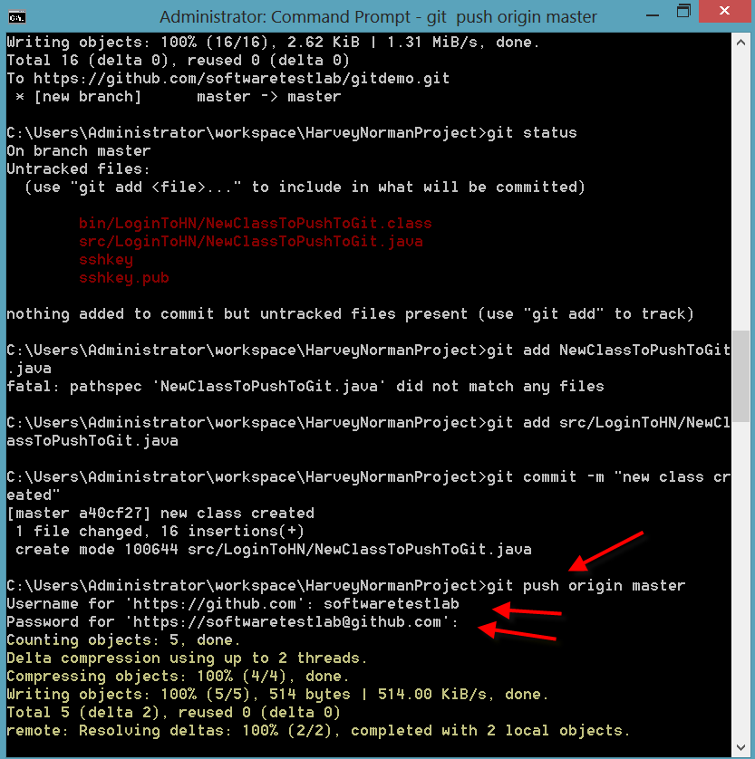

Now code is pushed to git..lets check on git for this new file

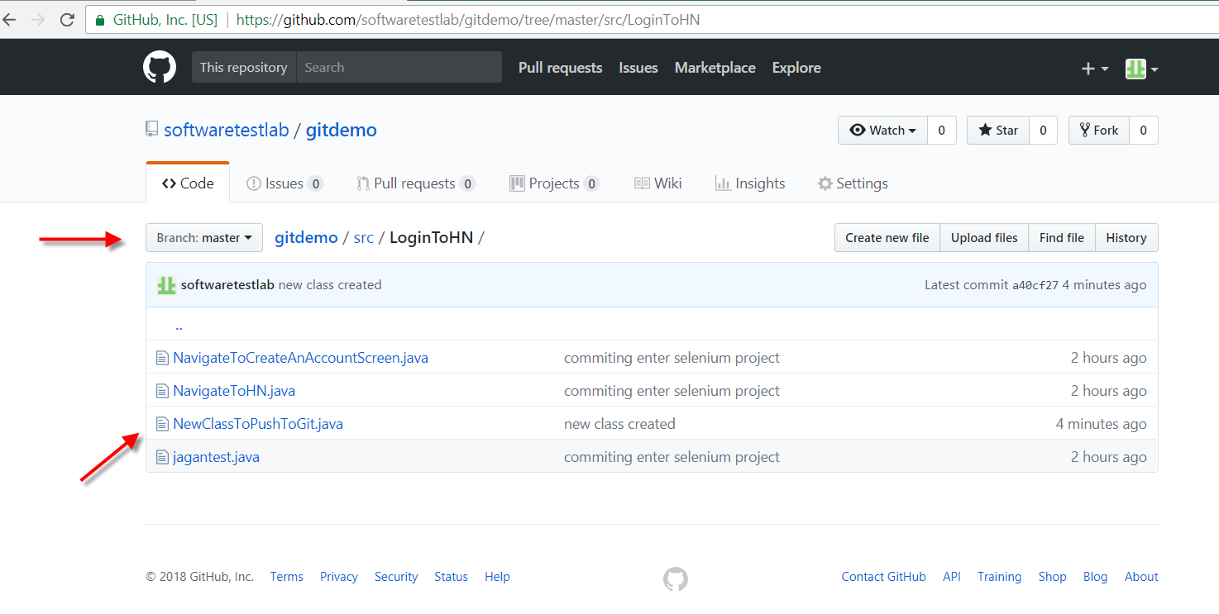

Now lets check how to pull code

Create a directory on your computer ..were you want to pull the code to from git

Go to cmd prompt and create a new directory

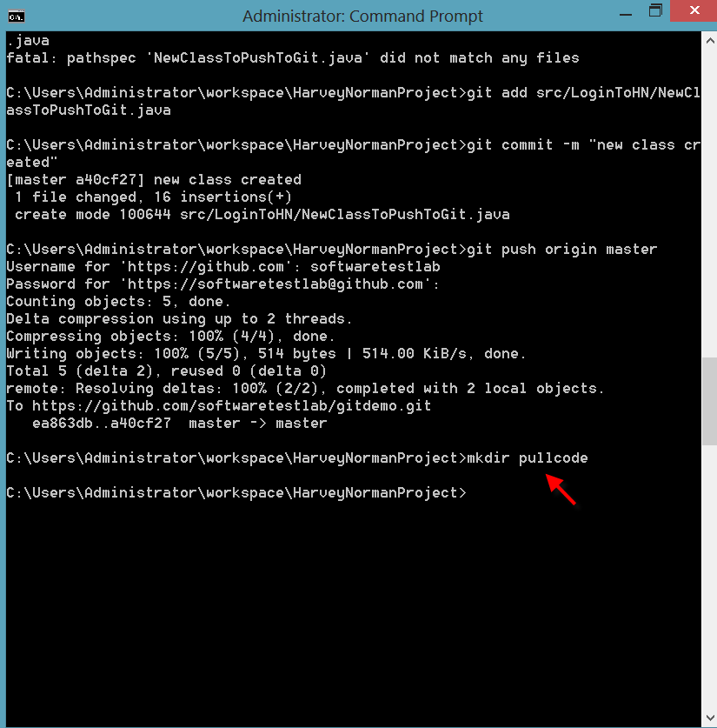

I have created a directory by name pullcode

Now cd to that directory

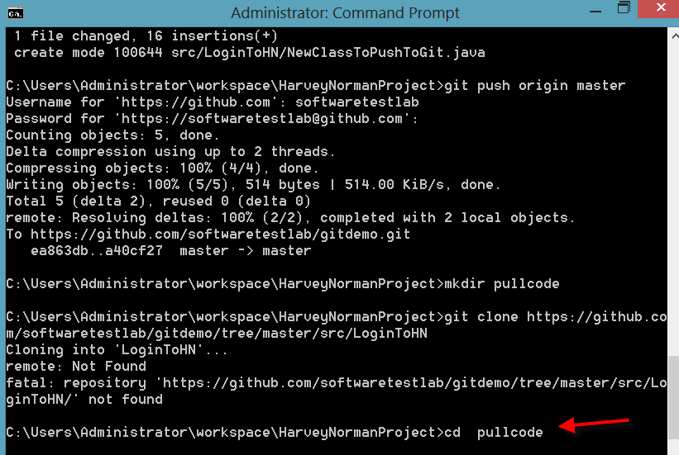

Now copy the path for repository from git and paste in cmd

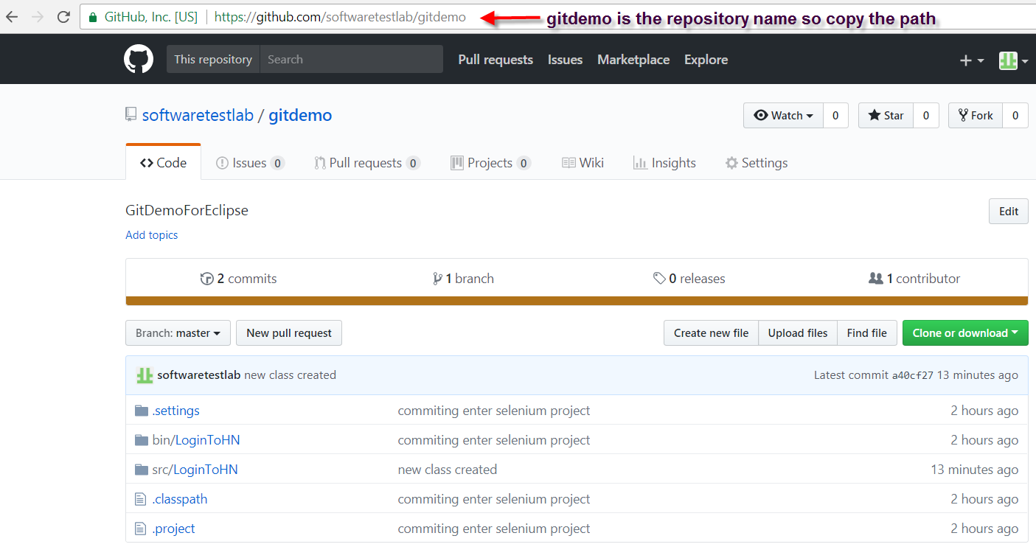

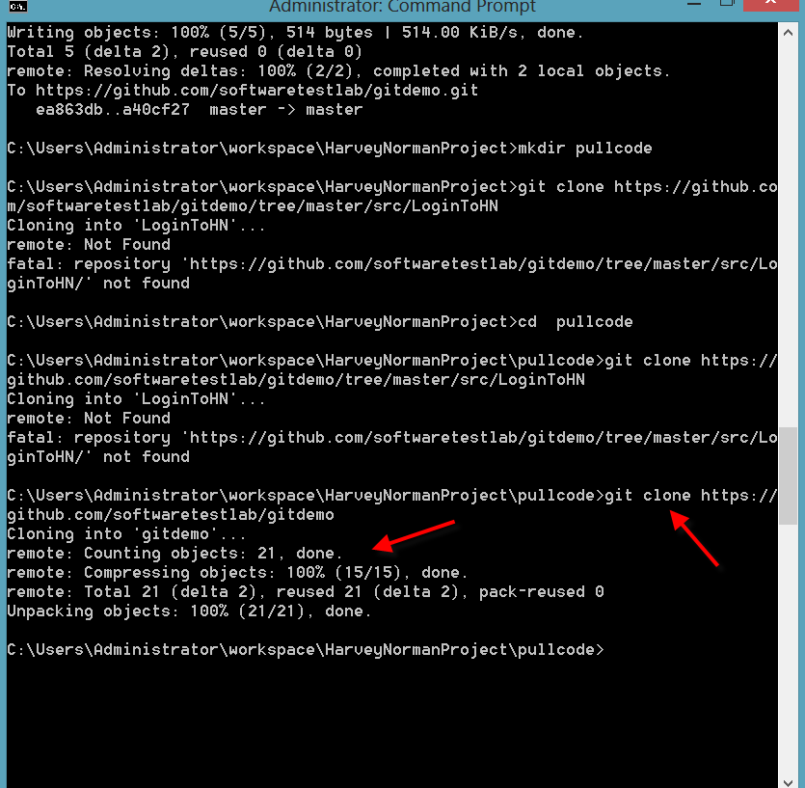

Cloning is done, now lets check in pullcode folder for this repository and you can see all the fodlers are copied from git to local

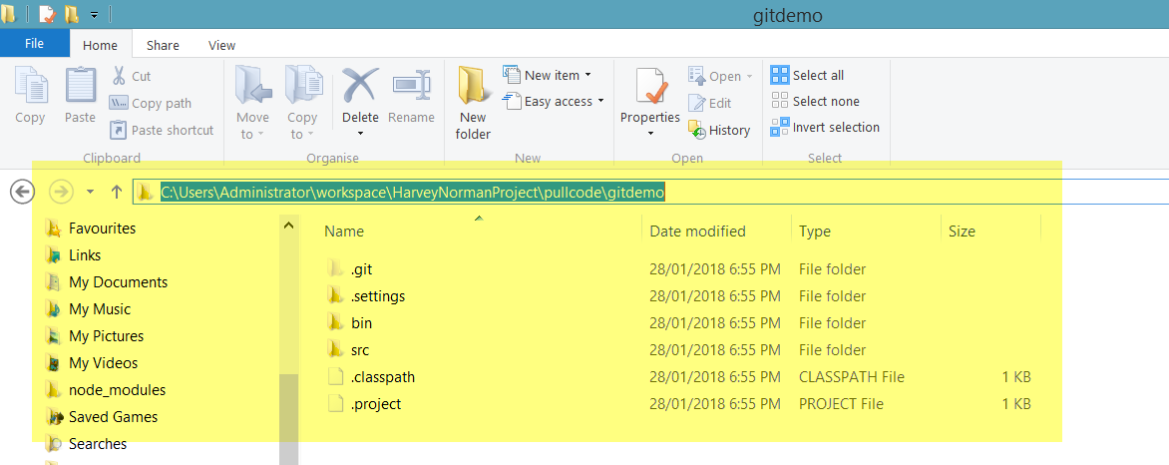

Now lets copy the imported project into eclipse

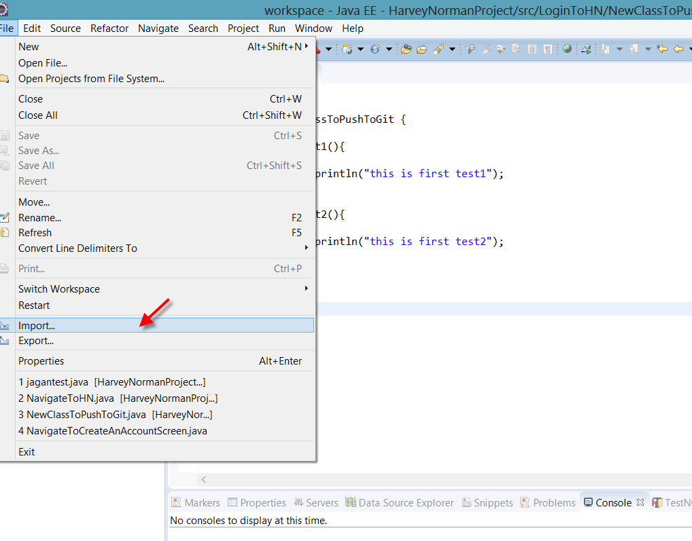

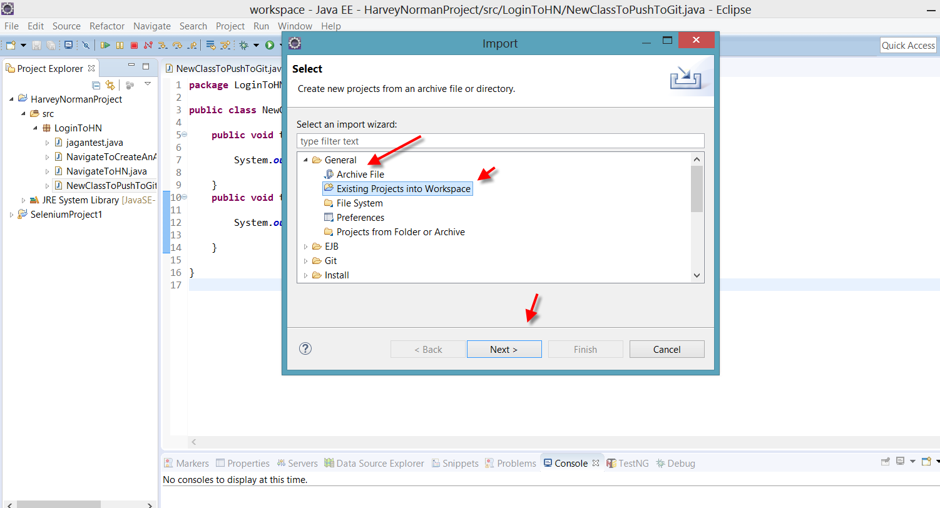

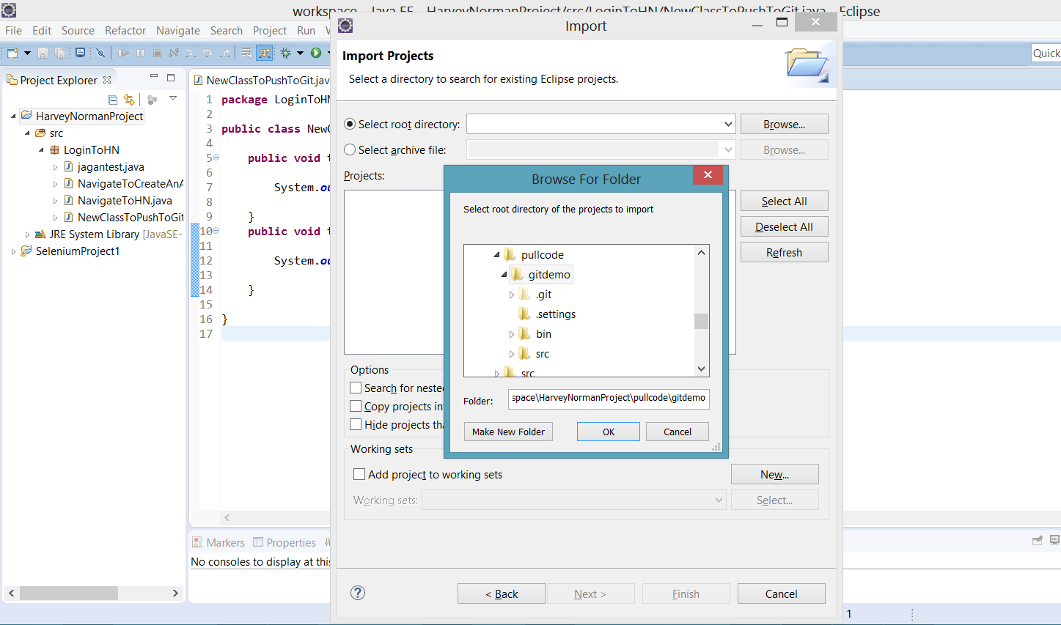

Now as its an existing project , eclipse didn’t accept but here the cocept was how to import and thats coverd

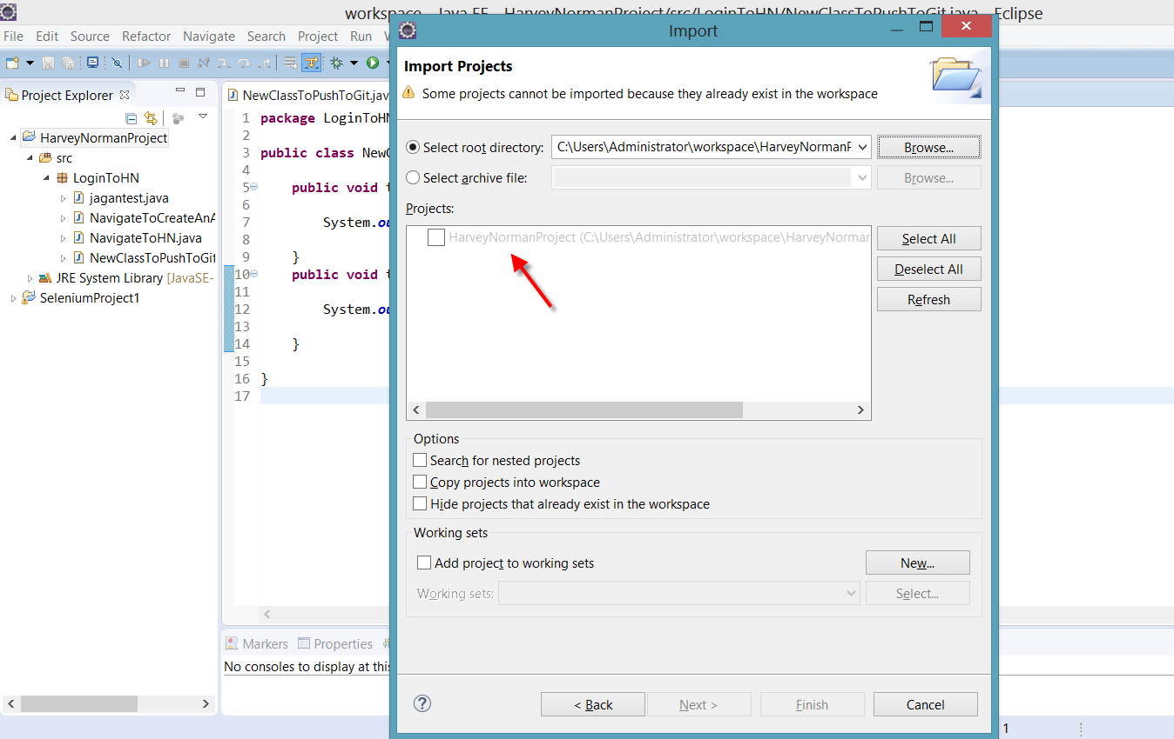

Clone is done only once to get an instance of the project on to your local drive

Now lets suppose a file is update in the repository which is present in git

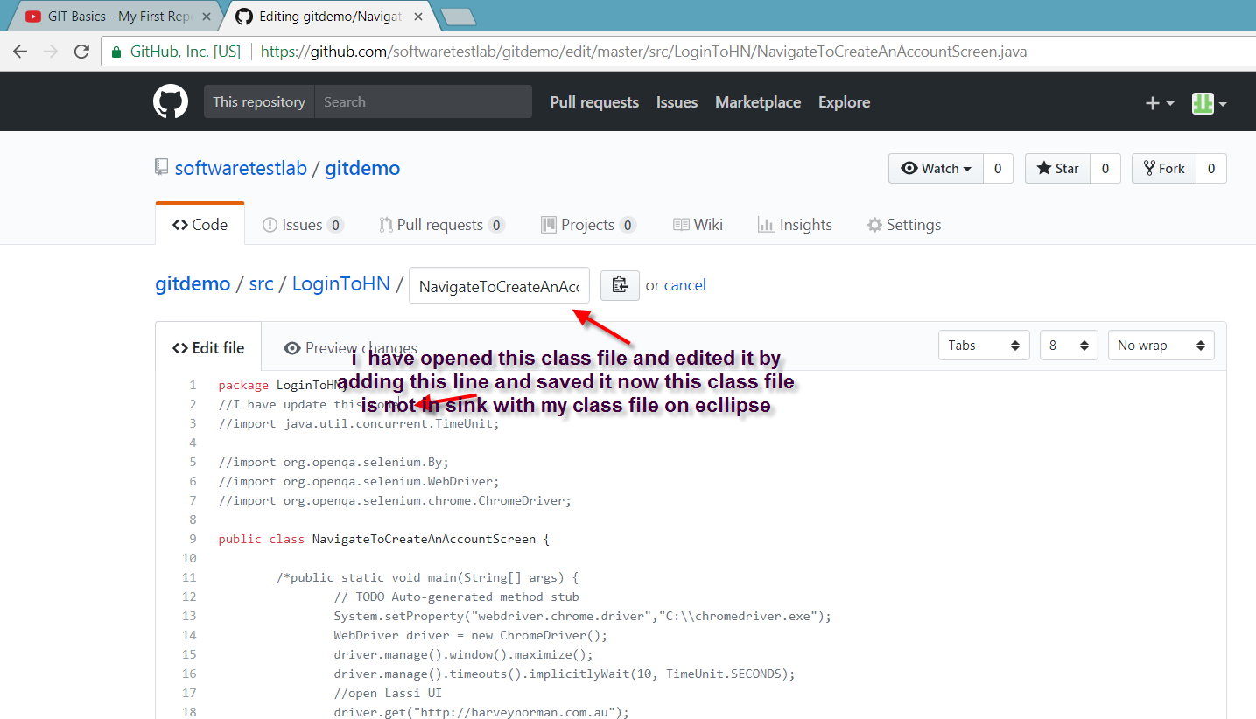

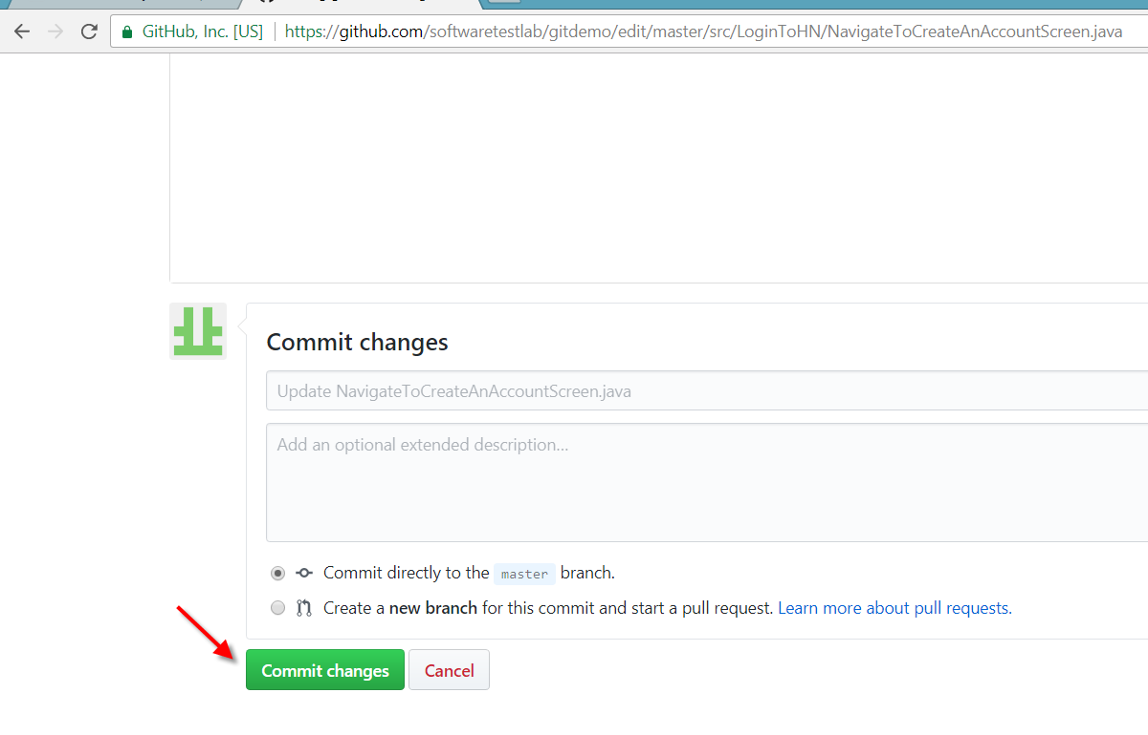

Cd to the direcotory were the project is located

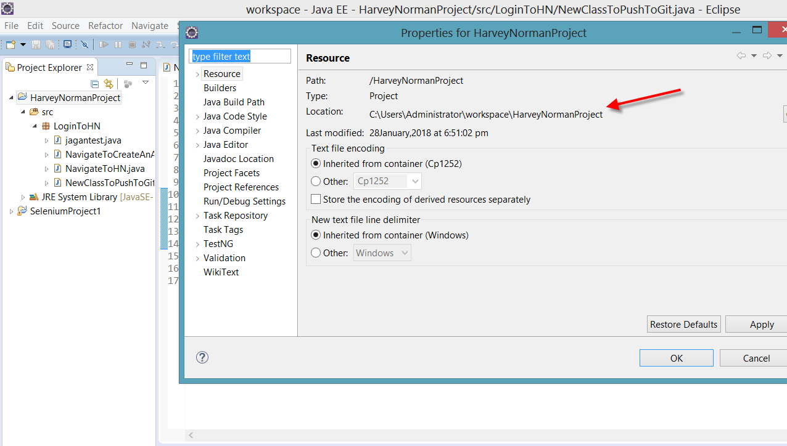

Pull is the one we have to do

